**BANK LOAN REPORT QUERY DOCUMENT**

**KPI’s:**

**Total Loan Applications**

SELECT COUNT(id) AS Total_Applications FROM bank_loan_db

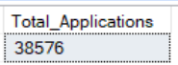

**MTD Loan Applications**

SELECT COUNT(id) AS MTD_Total_Applications FROM bank_loan_db

WHERE MONTH(issue_date) =12 AND YEAR(issue_date) = 2021



**Previous MTD Loan Applications**

SELECT COUNT(id) AS PMTD_Total_Applications FROM bank_loan_db

WHERE MONTH(issue_date) =11 AND YEAR(issue_date) = 2021



**Total Funded Amount**

SELECT SUM(loan_amount) AS Total_Funded_Amount FROM bank_loan_db



**MTD Total Funded Amount**

SELECT SUM(loan_amount) AS MTD_Total_Funded_Amount FROM bank_loan_db

WHERE MONTH(issue_date) =12 AND YEAR(issue_date) = 2021



**PMTD Total Funded Amount**

SELECT SUM(loan_amount) AS MTD_Total_Funded_Amount FROM bank_loan_db

WHERE MONTH(issue_date) =11 AND YEAR(issue_date) = 2021



**Total Amount Received**

SELECT SUM(total_payment) AS Total_Amount_Collected FROM bank_loan_db



**MTD Total Amount Received**

SELECT SUM(total_payment) AS MTD_Total_Amount_Collected FROM bank_loan_db

WHERE MONTH(issue_date) =12 AND YEAR(issue_date) = 2021



*Copyrights – Anurag Pandey*

**PMTD Total Amount Received**

SELECT SUM(total_payment) AS MTD_Total_Amount_Collected FROM bank_loan_db

WHERE MONTH(issue_date) =11 AND YEAR(issue_date) = 2021



**Average Interest Rate**

SELECT AVG(int_rate)*100 AS Avg_Int_Rate FROM bank_loan_db



**MTD Average Interest**

SELECT AVG(int_rate)*100 AS MTD_Avg_Int_Rate FROM bank_loan_data

WHERE MONTH(issue_date) = 12 AND YEAR(issue_date) = 2021



**PMTD Average Interest**

SELECT AVG(int_rate)*100 AS PMTD_Avg_Int_Rate FROM bank_loan_data

WHERE MONTH(issue_date) = 11 AND YEAR(issue_date) = 2021



**Avg DTI**

SELECT AVG(dti)*100 AS Avg_DTI FROM bank_loan_db



**MTD Avg DTI**

SELECT AVG(dti)*100 AS MTD_Avg_DTI FROM bank_loan_db

WHERE MONTH(issue_date) = 12 AND YEAR(issue_date) = 2021



**PMTD Avg DTI**

SELECT AVG(dti)*100 AS MTD_Avg_DTI FROM bank_loan_data

WHERE MONTH(issue_date) = 11 AND YEAR(issue_date) = 2021



**GOOD LOAN ISSUED**

**Good Loan Percentage**

SELECT

(COUNT(CASE WHEN loan_status = 'Fully Paid' OR loan_status = 'Current' THEN id END) * 100.0) /

COUNT(id) AS Good_Loan_Percentage

FROM bank_loan_db



**Good Loan Applications**

SELECT COUNT(id) AS Good_Loan_Applications FROM bank_loan_db

WHERE loan_status = 'Fully Paid' OR loan_status = 'Current'



**Good Loan Funded Amount**

SELECT SUM(loan_amount) AS Good_Loan_Funded_amount FROM bank_loan_db

WHERE loan_status = 'Fully Paid' OR loan_status = 'Current'



**Good Loan Amount Received**

SELECT SUM(total_payment) AS Good_Loan_amount_received FROM bank_loan_db

WHERE loan_status = 'Fully Paid' OR loan_status = 'Current

**BAD LOAN ISSUED**

**Bad Loan Percentage**

SELECT

(COUNT(CASE WHEN loan_status = 'Charged Off' THEN id END) * 100.0) /

COUNT(id) AS Bad_Loan_Percentage

FROM bank_loan_db



**Bad Loan Applications**

SELECT COUNT(id) AS Bad_Loan_Applications FROM bank_loan_db

WHERE loan_status = 'Charged Off'



**Bad Loan Funded Amount**

SELECT SUM(loan_amount) AS Bad_Loan_Funded_amount FROM bank_loan_db

WHERE loan_status = 'Charged Off'



**Bad Loan Amount Received**

SELECT SUM(total_payment) AS Bad_Loan_amount_received FROM bank_loan_db

WHERE loan_status = 'Charged Off'



*Copyrights – Anurag Pandey*

**LOAN STATUS**

**Total Loan status of Applications**

SELECT

loan_status,

COUNT(id) AS LoanCount,

SUM(total_payment) AS Total_Amount_Received,

SUM(loan_amount) AS Total_Funded_Amount, AVG(int_rate * 100) AS Interest_Rate, AVG dti * 100) AS DTI

FROM

bank_loan_db

GROUP BY

loan_status

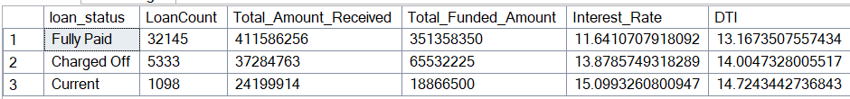

**Total MTD Loan status of Funded/Received**

SELECT

loan_status,

SUM(total_payment) AS MTD_Total_Amount_Received,

SUM(loan_amount) AS MTD_Total_Funded_Amount

FROM bank_loan_db

WHERE MONTH(issue_date) = 12

GROUP BY loan_status

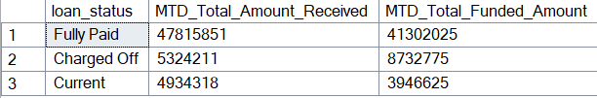

*Copyrights – Anurag Pandey*

1. **BANK LOAN REPORT | OVERVIEW**

**MONTH**

**Total Monthly Report By Funded/Received**

SELECT

MONTH(issue_date) AS Month_Munber,

DATENAME(MONTH, issue_date) AS Month_name,

COUNT(id) AS Total_Loan_Applications,

SUM(loan_amount) AS Total_Funded_Amount,

SUM(total_payment) AS Total_Amount_Received

FROM bank_loan_data

GROUP BY MONTH(issue_date), DATENAME(MONTH, issue_date)

ORDER BY MONTH(issue_date)

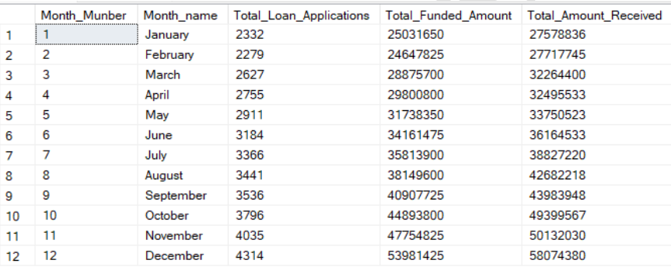

*Copyrights – Anurag Pandey*

**STATE**

**Total State wise Report( Funded/Received)**

SELECT

address_state AS State,

COUNT(id) AS Total_Loan_Applications,

SUM(loan_amount) AS Total_Funded_Amount,

SUM(total_payment) AS Total_Amount_Received

FROM bank_loan_db

GROUP BY address_state

ORDER BY address_state

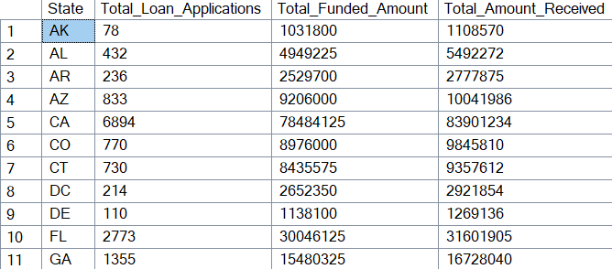

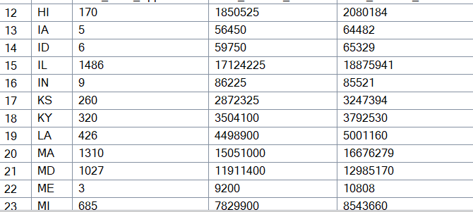

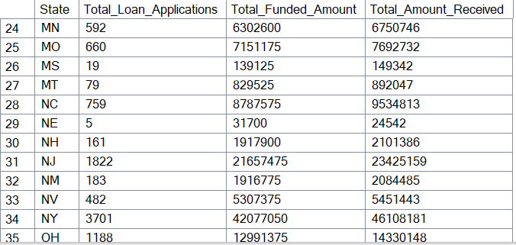

*Copyrights – Anurag Pandey*

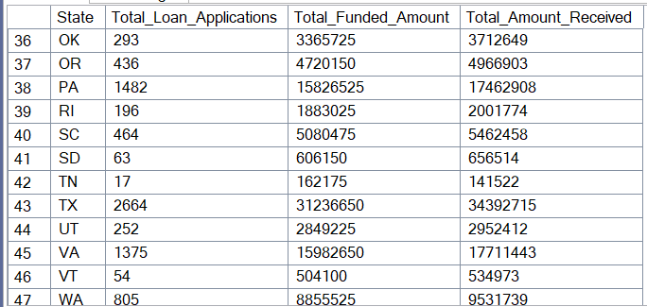

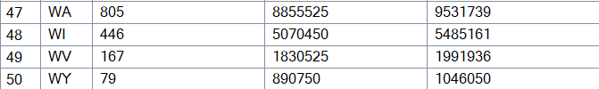

**TERM**

**Term wise Report ( Applications/Funded/Received)**

SELECT

term AS Term,

COUNT(id) AS Total_Loan_Applications,

SUM(loan_amount) AS Total_Funded_Amount,

SUM(total_payment) AS Total_Amount_Received

FROM bank_loan_db

GROUP BY term

ORDER BY term

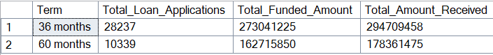

*Copyrights – Anurag Pandey*

**EMPLOYEE LENGTH**

**Report By Employee_Length ( Applications/Funded/Received)**

SELECT

emp_length AS Employee_Length,

COUNT(id) AS Total_Loan_Applications,

SUM(loan_amount) AS Total_Funded_Amount,

SUM(total_payment) AS Total_Amount_Received

FROM bank_loan_db

GROUP BY emp_length

ORDER BY emp_length

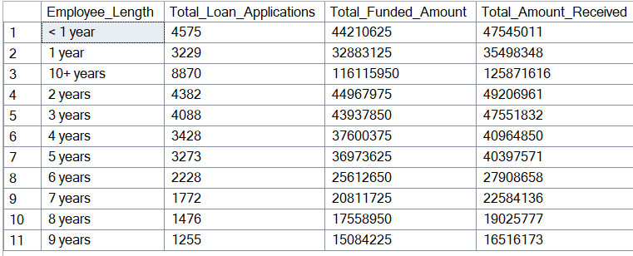

*Copyrights – Anurag Pandey*

**PURPOSE**

**Report By Purpose ( Applications/Funded/Received)**

SELECT

purpose AS PURPOSE,

COUNT(id) AS Total_Loan_Applications,

SUM(loan_amount) AS Total_Funded_Amount,

SUM(total_payment) AS Total_Amount_Received

FROM bank_loan_db

GROUP BY purpose

ORDER BY purpose

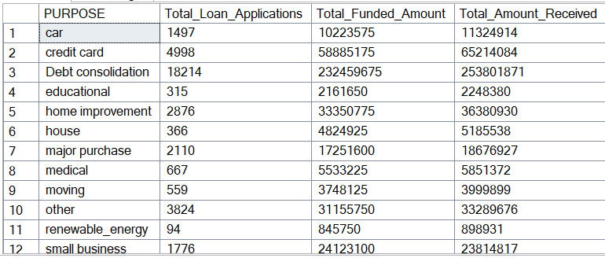



*Copyrights – Anurag Pandey*

**HOME OWNERSHIP**

**Report By HomeOwnership ( Applications/Funded/Received)**

SELECT

home_ownership AS Home_Ownership,

COUNT(id) AS Total_Loan_Applications,

SUM(loan_amount) AS Total_Funded_Amount,

SUM(total_payment) AS Total_Amount_Received

FROM bank_loan_db

GROUP BY home_ownership

ORDER BY home_ownership

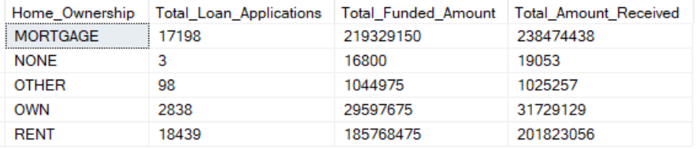

*Note: We have applied multiple Filters on all the dashboards. You can check the results for the filters as well by modifying the query and comparing the results.*

*For e.g*

*See the results when we hit the Grade A in the filters for dashboards.*

*SELECT*

*purpose AS PURPOSE,*

*COUNT(id) AS Total_Loan_Applications,*

*SUM(loan_amount) AS Total_Funded_Amount,*

*SUM(total_payment) AS Total_Amount_Received*

*FROM bank_loan_db*

*WHERE grade = 'A'*

*GROUP BY purpose*

*ORDER BY purpose*

*Copyrights – Anurag Pandey*